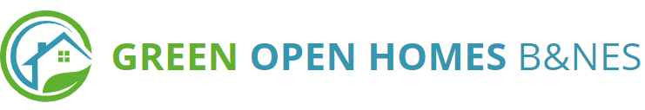
Would you like to run a Green Open Homes in your community to tackle the energy and climate crisis, but need support?

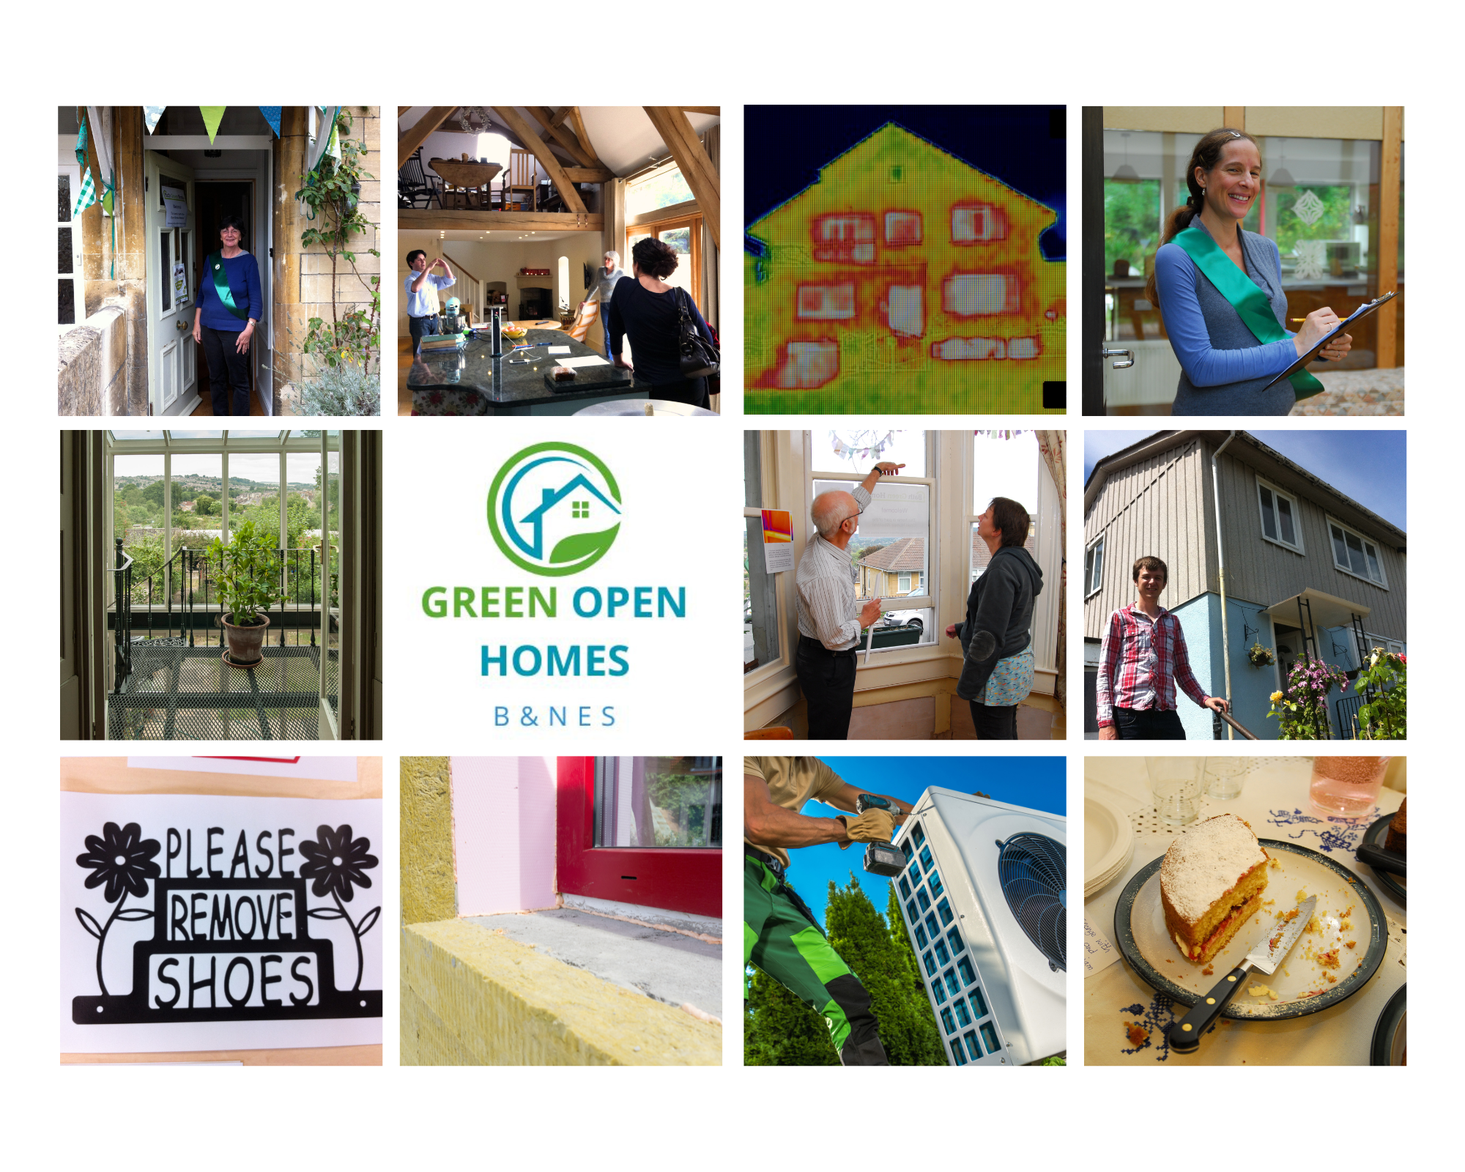

Open Homes events showcase exemplary energy efficient homes in an area, much like an arts trail. Visitors get first hand advice without talking to a salesperson on measures such as solar panels, insulation, triple glazing, or new heating. Around 70% of visitors go on to retrofit their homes.

Bath & West Community Energy (BWCE) are delighted to be coordinating Green Open Homes B&NES, a programme of resources and capacity for Open Homes events to be run in partnership with B&NES communities until March 2025.

Our first event will be in Bath on November 4th & 5th, in partnership with Transition Bath, B&NES Council, Bath Preservation Trust and Buro Happold. We could support one other community to open homes that weekend – please get in touch if you would like more information. For this or future events, support could include:

- A page for your Open Homes event on our website (currently under development) and publicity campaigns, to complement any local publicity.
- Help from our experienced project staff
- Insurance, materials and briefings for home openers and volunteers.
- A booking system for visitors if requested by home openers
- A case study writeup of the homes
Next steps: For more information or to put your community forward this year or for future years, please contact BWCE Green Open Homes B&NES Coordinator, Nicola Passam: nicola.passam@bwce.org

For further information please see our holding page (full website under development) https://www.greenhomesbanes.org/

