

**Cold Weather Plan for England:**

**Bath and North East Somerset Delivery Framework**

|  |  |
| --- | --- |
| **Valid From** | **28/12/2022** |
| **Date of Issue** | **28/12/2022** |

Contents

1. Introduction 2

1.1 Plan Activation 2

1.2 Associated Plans & Documents 3

1.3 Aim 3

1.4 Objectives 3

1.4 Limitations 3

2. Cold Weather Alert Service 4

3. Alert Distribution 4

4. Roles and Responsibilities 5

4.1 All Services: Generic Actions 6

4.2 Emergency Management 6

4.3 Public Health 7

4.4 Commissioners of Health and Social Care and Local Authority 7

4.5 Provider Organisations for Health & Social Care 9

4.6 Frontline Staff for Health and Social Care 11

4.7 Voluntary and Community Sector 13

# **Introduction**

Key public health messages and detailed guidance are available in the [Cold Weather Plan for England 2022-2023.](https://assets.publishing.service.gov.uk/government/uploads/system/uploads/attachment_data/file/1115873/2022-to-2023-cold-weather-plan-for-England.pdf)

## **1.1 Plan Activation**

Level 1 of this plan will be activated annually in line with the Met Office Cold Weather Alert Service on the 1st of November until the 31st of March, after this time the risk of severe cold weather is negligible.

Notification of activation and any subsequent alert will be communicated to Strategic and Service managers as well as community and voluntary organisations by Emergency Management via an email alert.

## **Associated Plans & Documents**

* The Cold Weather Plan for England (UK Health Security Agency)
* Cold Weather plan for England: Making the case why long-term strategic planning for cold weather is essential to health and wellbeing (UK Health Security Agency)

## **Aim**

The aim of this plan is to outline the processes and arrangements in place across Bath and North East Somerset to deliver the actions outlined in the Cold Weather Plan for England.

## **1.4 Objectives**

* To outline the Met Office Cold Weather Alert system and how it is delivered across the local authority;
* Outline the roles, responsibilities, and expectations of those in receipt of Cold Weather Health Watch alerts; and
* To provide an example alert and supporting guidance/resources

This will ensure:

* Advanced warning and advice are available to staff across BANES leading up to and during periods of severe cold weather;
* Commissioners and providers are aware of actions necessary to support vulnerable people during periods of cold weather;
* Appropriate and timely advice & guidance is made available to partner agencies, the voluntary sector, carers and individuals; and
* The wider population of BANES are aware of the risks and subsequent actions they can take to protect both themselves and those most vulnerable to cold weather conditions.

## **Limitations**

The Cold Weather Plan for England is a UK Health Security Agency document and therefore focuses on the negative health effects of prolonged periods of cold weather. Whilst practical and logistical considerations are integral to continue essential health services, these are made within business continuity arrangements across the authority.

This plan provides an overview of service area responsibilities in relation to the Cold Weather Plan for England. Whilst action cards and prompts will be provided as part of the alerting mechanism, each service area should consider these responsibilities and develop appropriate processes and arrangements through which to deliver them.

# **Cold Weather Alert Service**

The cold weather alert service is delivered to the Public Health and Emergency Planning teams by the Met Office and operates in England from November 1st to March 31st. During this period severe cold weather may be forecast, as defined by

* Mean temperatures of 2°C or less for at least 48 hours; and/or
* Widespread ice and heavy snow

The service comprises five main levels of alert (0-4) outlined as follows:

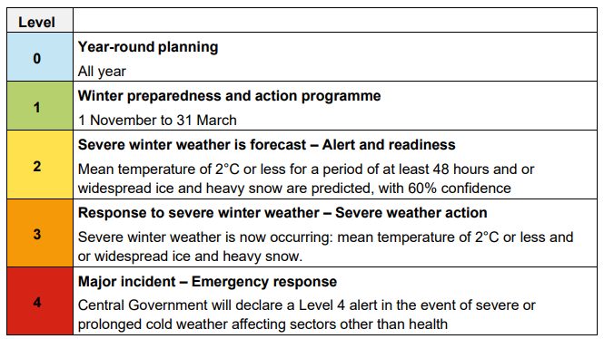

An alert will be issued for ‘cold’ temperatures if there is a high likelihood that the mean temperature is expected to be at or below 2°C for a period of 48 hours in one or more regions in the next five days.

A level 2 will be issued when these conditions are forecast and a level 3 when they are occurring.

# **Alert Distribution**

Alerts are distributed to Strategic and Service managers as well as community and voluntary organisations via email during office hours. See Appendix 1 for example email alert.

Wider Met Office Distribution to responders and professional partners is as follows:

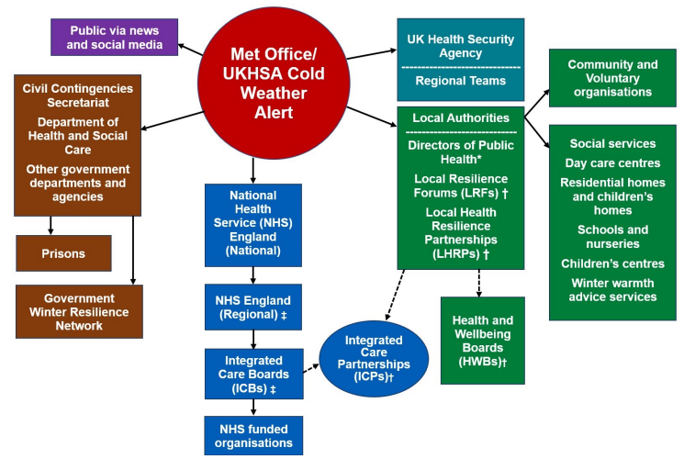

# **Roles and Responsibilities**

All service areas are themselves responsible for ensuring familiarisation and embedding of the following actions within their service delivery. Further advice and guidance on delivering these actions can be found in the Cold Weather Plan for England.

Key public health messages and detailed guidance are available in the [Cold Weather Plan for England 2022-2023.](https://assets.publishing.service.gov.uk/government/uploads/system/uploads/attachment_data/file/1115873/2022-to-2023-cold-weather-plan-for-England.pdf)

Summary actions for key local authority services are as follows:

## **4.1 All Services: Generic Actions**

|  |  |
| --- | --- |
| **Level** | **Action** |
| **0** | * Consider the impacts of prolonged cold weather on the health & safety of your staff and delivery of services; * Where possible mitigate any identified risks; and * Incorporate any special measures into your business continuity arrangements. |
| **1** | * Consider the health & safety of your staff and potential impacts on service delivery, such as staffing demands and any likely escalation; * Ensure your direct and commissioned services are aware of the change in alert level; * Consider the effect of any service level impacts on the wider authority; * Implement your business continuity plan and arrangements as required; and * Contact the Emergency Management Team if operational support or assistance is required. |
| **2** |
| **3** |
| **4** | Central government will declare a Level 4 alert in the event of severe or prolonged cold weather affecting sectors other than health and if requiring coordinated multi-agency response.   * Continue previous actions * Escalation and activation of associated corporate response plans will be communicated as appropriate in accordance with existing procedures |

## **Emergency Management**

|  |  |
| --- | --- |
| **Level** | **Action** |
| **0** | Maintain, distribute and review the Cold Weather Plan for England: Bath and North East Somerset Delivery Framework and related arrangements against national guidance, organisational changes and lessons learnt |
| **1** | * Receive and cascade Met Office Cold Weather Health Watch alerts to distribution list * Provide advice, guidance and support for any local authority services implementing business continuity arrangements during periods of cold weather. * Consider wider context and implications of any developing situation and activate associated plans as appropriate |
| **2** |
| **3** |
| **4** | Central government will declare a Level 4 alert in the event of severe or prolonged cold weather affecting sectors other than health and if requiring coordinated multi-agency response.   * All level 1 - 3 responsibilities to be maintained alongside wider corporate responsibilities. |

## **Public Health**

|  |  |
| --- | --- |
| **Level** | **Action** |
| **0** | Support Emergency Management in maintaining and reviewing the Cold Weather Plan for England: Bath and North East Somerset Delivery Framework and related arrangements against national guidance, organisational changes and lessons learnt. |
| **1** | * Receive and cascade Met Office Cold Weather Health Watch alerts to distribution list if Emergency Management is unavailable. * Share communications toolkit for cold weather alerts with stakeholders * Share information of expected roles and responsibilities of receiving organisations * Liaise with Emergency Management Team for advice, guidance and support to resolve business continuity problems * Contact the Community Wellbeing Hub for other services. * Provide health protective measures advice in the case of a cold spell including on social media and in newsletters. |
| **2** |
| **3** |
| **4** | Central government will declare a Level 4 alert in the event of severe or prolonged cold weather affecting sectors other than health and if requiring coordinated multi-agency response   * All level 1 - 3 responsibilities to be maintained alongside wider corporate responsibilities. |

## **Commissioners of Health and Social Care and Local Authority**

|  |  |
| --- | --- |
| **Level** | **Action** |
| **0** | * Work with partner agencies to ensure that cold weather planning features within wider winter resilience planning. * Work with partner agencies to:   + identify those most at risk from seasonal variations   + improve winter resilience of those at risk   + ensure a local, joined-up programme is in place to support improved housing, heating and insulation, including uptake of energy efficient, low carbon solutions   + achieve a reduction in carbon emissions and assess the implications of climate change * Consider how your winter plans can help to reduce health inequalities, target high risk groups and address the wider determinants of health. * Ensure that organisations and staff are prompted to signpost vulnerable clients onwards (eg for energy efficiency measures, benefits or related advice). * Work with partners and staff on risk reduction awareness (eg flu vaccination for staff in September/October), information and education. * Engage with local VCS organisations for planning and implementation of all stages of the plan |
| **1** | * Communicate public health media messages. * Consider the revisions to the CWP and ensure that the changes are understood across the system. Work with partner agencies to co-ordinate locally appropriate cold weather plans. * Ensure key partners, including all managers of care, residential and nursing homes are aware of the alert system and can access advice. * Review the distribution of the alerts across the system and ensure staff are aware of winter plans and advice. * Ensure that local organisations and professionals are taking appropriate actions in light of the cold weather alerts in accordance with local and national CWP. * Ensure that organisations and staff are prompted to signpost vulnerable clients onwards (eg for energy efficiency measures, benefits or related advice). * Liaise with providers of emergency shelter for homeless people to agree plans for severe weather and ensure capacity to scale up provision. * Support communities to help those at risk. * Support the development of community emergency plans. * Identify which local health, social care and voluntary and community sector organisations are most vulnerable to the effects of winter weather. Agree plans for winter surge in demand for services. Make sure emergency contacts are up to date |
| **2** | * Continue to communicate public health messages. * Communicate alerts to staff and make sure that they can take appropriate actions. * Ensure partners, including all managers of care, residential & nursing homes are aware of the alerts and can access advice. * Support local VCS organisations to activate community emergency plans. * Activate business continuity arrangements and emergency plans as required. * Consider how to make best use of available capacity, for example by using community beds for at risk patients who do not need an acute bed and enabling access to step-down care and reablement. * Work with partner agencies (eg transport) to ensure road/ pavement gritting preparations are in place to allow access to critical services and pedestrian hotspots. |
| **3** | * Continue to communicate public health messages. * Communicate alerts to staff and make sure that winter plans are in operation. * Ensure key partners are undertaking action in response to alerts. Support local voluntary and community sector organisations to mobilise community emergency plans. * Ensure continuity arrangements are working with provider organisations. * Work with partner agencies (eg transport) to ensure road/ pavement gritting arrangements are in effect to allow access to critical services and pedestrian hotspots |
| **4** | * Central government will declare a level 4 alert in the event of severe or prolonged cold weather affecting sectors other than health. Response likely to involve:   + national government departments   + executive agencies   + public sector, including health sector   + voluntary and community sector * All level 3 responsibilities must be maintained during a level 4 incident Implementation of national emergency response arrangements by central government |

## **Provider Organisations for Health & Social Care**

|  |  |
| --- | --- |
| **Level** | **Action** |
| **0** | * Ensure that you are engaged with local EPRR and other strategic arrangements. * Ensure that your organisation can identify those most vulnerable to cold weather and draw up plans for joined-up support with partner organisations. * Agree data-sharing arrangements within information governance principles. * Assess the longer-term implications of climate change; reduction in carbon emissions; and sustainability for longer-term business continuity. * Consider how to best mobilise and engage voluntary and community sector organisations and support the development and implementation of community emergency plans. * Make sure that staff have identified all those vulnerable to cold weather and that arrangements are in place to support and protect them appropriately. * Work with staff on risk reduction awareness, information and education. Encourage staff to be vaccinated against flu before winter starts. * Ensure that the business continuity plan includes severe winter weather. Plan for a winter surge in demand for services. * Consider carers needs and support they can continue to give. * Work with environmental health officers on HHSRS hazard identification |
| **1** | * Ensure that CW alerts are going to the right staff and appropriate actions are agreed and able to be implemented, especially to protect vulnerable clients. * Make sure that staff have identified all those vulnerable to cold weather and that arrangements are in place to support them appropriately. * Ensure staff are undertaking appropriate home checks when visiting clients, eg room temperature; medications and food supplies. * Hospitals and care, residential and nursing homes: ensure that rooms, particularly living rooms and bedrooms are kept warm and that staff are taking appropriate action to protect residents from cold weather. * Work with partner agencies to co-ordinate cold weather plans; ensure data sharing and referral arrangements are in place. * Continue to work with staff on risk reduction awareness, information and education. Encourage staff to be vaccinated against flu, if not already. * Work with local authority teams to identify accident hotspots on pavements or roads, advise on gritting priorities to prevent accidents, and ensure access by utilities and other essential services. * Ensure staff aware of the business continuity plan for winter weather; plan for a winter surge in demand. * Ensure carers are receiving advice and support |
| **2** | * Communicate alerts to staff and ensure that locally agreed CWP actions take place, especially those to protect vulnerable patients/ clients. * Continue to ensure local actions for the vulnerable such as:   + arranging daily contacts/visits   + ensuring staff are undertaking appropriate home checks when visiting clients, eg room temperature; medications and food supplies   + ensure carers are receiving appropriate advice and support. * Hospitals and care, residential and nursing homes: continue to ensure that rooms, particularly living rooms and bedrooms are kept warm. * Activate business continuity arrangements and emergency plans as required. * Activate plans to deal with a surge in demand for services. |
| **3** | * Communicate alerts to staff and ensure that locally agreed actions take place, especially those to protect vulnerable patients/clients. * Implement local plans for contacting the vulnerable. * Consider daily visits/ phone calls for high-risk individuals living on their own who have no regular contacts. * Ensure carers are receiving appropriate advice and support. * Implement plans to deal with surge in demand. * Implement business continuity arrangements |
| **4** | * Central government will declare a level 4 alert in the event of severe or prolonged cold weather affecting sectors other than health. * All level 3 responsibilities must be maintained during a level 4 incident. * Implementation of national emergency response arrangements by central government. * Continue to implement business continuity arrangements. |

## **Frontline Staff for Health and Social Care**

|  |  |
| --- | --- |
| **Level** | **Action** |
| **0** | * Work within your organisation and with partner organisations to ensure that systems are developed to support the identification and sharing of information between agencies of people who may be vulnerable to cold weather. * Systematically work to improve the resilience of vulnerable people to severe cold. * Ensure that all staff have been made aware of the cold weather plan and the dangers of cold weather to health and know how to spot signs and symptoms. * Use clinic attendances and home visits as opportunities to identify vulnerable people and discuss winter preparedness. * Work with at-risk individuals, their families and carers to ensure that they are aware of the dangers of cold weather and cold housing and how access support; ensure that there are clear arrangements for ‘signposting’ to other services (eg home insulation schemes; benefits entitlements) when identified in “clinical” situations. * Work with partners to ensure that vulnerable patients/clients have access to fuel supplies. Link to energy supplier priority service registers as required. * Ensure that clients and colleagues are aware of, and taken advantage of flu and other vaccination programmes |
| **1** | * Identify those at risk on your caseload and make necessary changes to care plans for high-risk groups. * For those with multiple agency inputs, ensure that the key worker is clearly identified, and care plans consider measures to reduce risk from cold weather. * Check client’s room temperature if visiting. Ensure that they have at least one room which meets recommended room temperatures. * Remind clients of the actions they can take to protect themselves from the effects of severe cold; including warm clothing, warm food and drinks; keeping active as much as they are able within the context of their care plan. * Continue to “signpost” those at risk clients/ patients to other services (eg home insulation schemes; benefits entitlements) when identified in “clinical” situations; use the Keep Warm Keep Well booklet for up-to-date patient information and advice. * Use resources available to you for raising awareness of the health risks associated with winter weather and cold housing (for example, pharmacists have a key role in reminding people to have sufficient medicine and help with preventive medicines managements). * Encourage clients and colleagues to be vaccinated against flu, if not already. |
| **2** | * As appropriate, contact those most at risk and implement care plans. * Continue to check client’s room temperature if visiting to ensure that clients are warm. Ensure that they have at least one room which meets recommended room temperatures. * Ensure urgent signposting for those at risk (eg in cold housing) to appropriate services. * Continue to remind clients of the actions they can take to protect themselves from the effects of severe cold. * Consider how forecast weather conditions may impact on your work – and make appropriate arrangements. * Make sure you and your teams are prepared for an influx of weather-related injuries and illnesses. |
| **3** | * As appropriate, contact those at risk (visit, phone call) daily. * Ensure staff can help and advise clients. * Other actions as per level 2. * Maintain business continuity |
| **4** | Central government will declare a level 4 alert in the event of severe or prolonged cold weather affecting sectors other than health.   * Response likely to involve: * National government departments * Executive agencies * Public sector, including health sector * Voluntary and community sector   All level 3 responsibilities must be maintained during a level 4 incident  Implementation of national emergency response arrangements by central government |

## **Voluntary and Community Sector**

|  |  |
| --- | --- |
| **Level** | **Action** |
| **0** | * Engage with local statutory partners to agree how the community and voluntary sector can contribute to the local community resilience arrangements * Develop a community emergency plan to:   + identify and support vulnerable neighbours in the winter   + assess the impact severe weather might have on the provision and use of usual community venues   + ensure that pavements and public walkways are cleared of snow and ice in the local community   + agree support, resources and training to maximise effective use of volunteers   + support recruitment of volunteers   + agree mechanisms for distributing food, fuel, emergency heating, health, social care and other provision to vulnerable people   + review emergency housing and hostel provision   + agree arrangements with other community groups to maximise contact with vulnerable people.   + identify available services for vulnerable people and agree signposting arrangements with providers |
| **1** | * Test the community emergency plan to ensure that roles and responsibilities and actions are clear. * Set up rotas of willing volunteers to keep the community safe during inclement weather and to check on vulnerable people and neighbours. * Support the provision of appropriate advice about the health risks of cold weather/cold housing especially with vulnerable people. * Ensure that there is a business continuity plan for severe winter weather to ensure support can continue to be given to vulnerable people. * Actively engage vulnerable people known to be at risk and check on welfare regularly and support them to seek help if necessary. |
| **2** | * Activate the community emergency plan. * Activate the business continuity plan. * Continue to actively engage vulnerable people known to be at risk and check on welfare regularly and support them to seek help if necessary. * Stay tuned to the weather forecast. |
| **3** | * Implement community emergency plan * Contact vulnerable people to ensure they are safe and well and support them to seek help if necessary * Ensure volunteers are appropriately supported * Implement the business continuity plan. |
| **4** | * Central government will declare a level 4 alert in the event of severe or prolonged cold weather affecting sectors other than health. * Continue actions as per level 3 unless advised to the contrary. * Ensure volunteers are appropriately supported. |